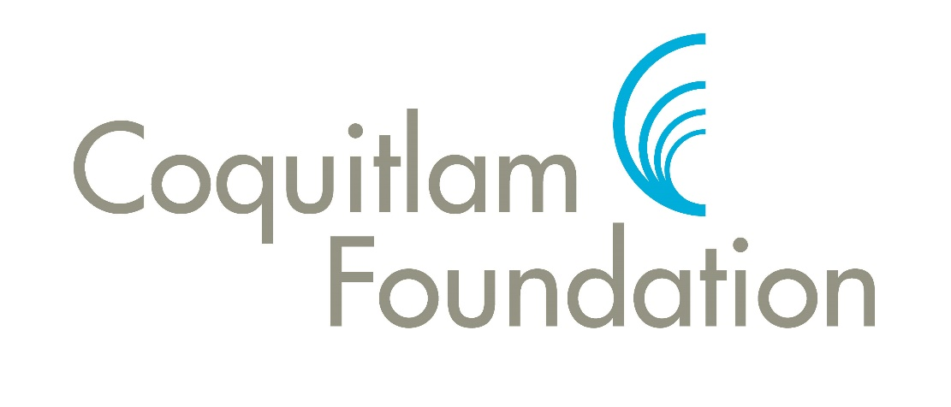

*“The Coquitlam Foundation encourages and supports creative, targeted philanthropy that builds a vibrant, sustainable, and healthy community.”*

# Serving as the charitable heart of Coquitlam since 1992

|  |  |
| --- | --- |
| Planting seeds of success | 2 |
| Focus on local TV production | 2 |
| HEALTH for  the homeless | 2 |
| A local man’s lasting legacy | 3 |
| Coquitlam SAR secures future | 3 |
| Promoting literacy | 3 |
| How you can participate | 4 |

**O**ur mission is to encourage and support creative, targeted philanthropy that builds a vibrant, sustainable, and healthy community.

We believe that the Coquitlam Foundation is both a catalyst and a resource for philanthropy throughout our community.

It is a vehicle for caring citizens who want to provide a benefit to our community in perpetuity. The Coquitlam Foundation is community-focused, meeting needs in the city, supporting service and compassion for the entire Coquitlam family and, by bringing together public and private interests, is a facilitator of change.

## Managing charitable funds and distributing grants

invest. enrich. inspire.

* We’ve awarded more than $1-million in grants, scholarships and bursaries.
* We manage $3.2-million in 24 donor-advised and five foundation-directed funds.

What’s Inside



We’re a proud member of the Community Foundations of Canada, which represents 191 foundations throughout the country

**F**ounded by an act of the B.C. Legislature in 1992, the Coquitlam Foundation has served the community continuously for a quarter of a century by:

*Distributing grants, scholarships and bursaries to worthy students and community organizations;

*Providing an efficient way for interested charitable organizations and individuals to steward their resources and accomplish their philanthropic goals through the establishment of donor-advised funds managed by the foundation.

Through the engagement of professional asset managers and guided by prudent policy decisions made at the board level, the foundation has been able to grow its endowment to more than $3.2 million—growth that was sustained even during difficult economic times.

A great many individuals and organizations, such as the Coquitlam Public Library and Coquitlam Search and Rescue, have shown their faith in our ability to manage their funds to allow them to achieve their charitable intentions.

The establishment in 2012 of the James Gordon Stewart Fund, following the bequest of $355,000 from his estate, further exemplifies the high level of trust that the community feels for the foundation.

“All these small steps forward have cumulatively spelled success for Tri-Cities Community Television. They can all be directly attributed to the Coquitlam Foundation being the first organization in the region to find a way to contribute to our efforts. We are very grateful, indeed.”

**G**eoff Scott, producer and founder of Tri-Cities Community Television (TCCTV), prefers to be behind his video camera, capturing the people, places and things that make Coquitlam and the rest of the Tri-Cities area so special.

But in the wake of the Coquitlam Foundation’s awarding of a $3,500 community grant to Scott and his organization in 2011, he spent some time on the other side of the camera, as the focus of favourable media attention.

Scott was able to use the grant money to launch the “Arts in Coquitlam” segment in his regular *Tri-Cities Magazine* show on Shaw Television.

He said the momentum created by the foundation’s grant led to the City of Port Coquitlam’s decision to invest $3,000 in TCCTV to help it develop a strategic plan. “All these small steps forward have cumulatively spelled success for Tri-Cities Community Television in 2011,” he concluded. “They can all be directly attributed to the Coquitlam Foundation being the first organization in the region to find a way to contribute to our efforts. We are very grateful, indeed.”

## Giving HEALTH to the region’s homeless

**A**s the sponsor of the Dr. Charles Best Secondary School’s “Best Buddies “ leadership club, then-counsellor Kristi Blakeway decided it would be a good idea to bring students to Vancouver’s Downtown Eastside so they could reach out and help the downtrodden area’s many homeless people.And thus was born Project HEALTH (Holiday Essentials and Love Towards the Homeless), through which the students helped the homeless reconnect with long-lost loved ones. In the spring of 2010, the Coquitlam Foundation was pleased to give Project HEALTH a grant of $1,250 to purchase a video camera so the homeless could send photos and video messages to their loved one.

**W**hen school ends for the day, and there’s no safe place for an at-risk student to go for the rest of the afternoon, what then? It is a question that was being asked in 2008 at Como Lake Middle School in Coquitlam. And the answer parents and educators settled on was the Kateslem After School Club, a no-fee program for 11- to 14-year-olds offering everything from homework help and life-skills education to community-service opportunities and sporting activities.

But funds were running out and the program was in jeopardy. The Coquitlam Foundation stepped in, granting Kateslem $3,500 in 2009. Principal Cindi Seddon said the funding ends up benefitting the entire community. “The more engaged we are with at-risk kids,” she said, “the less crime we’ll have on the streets.”

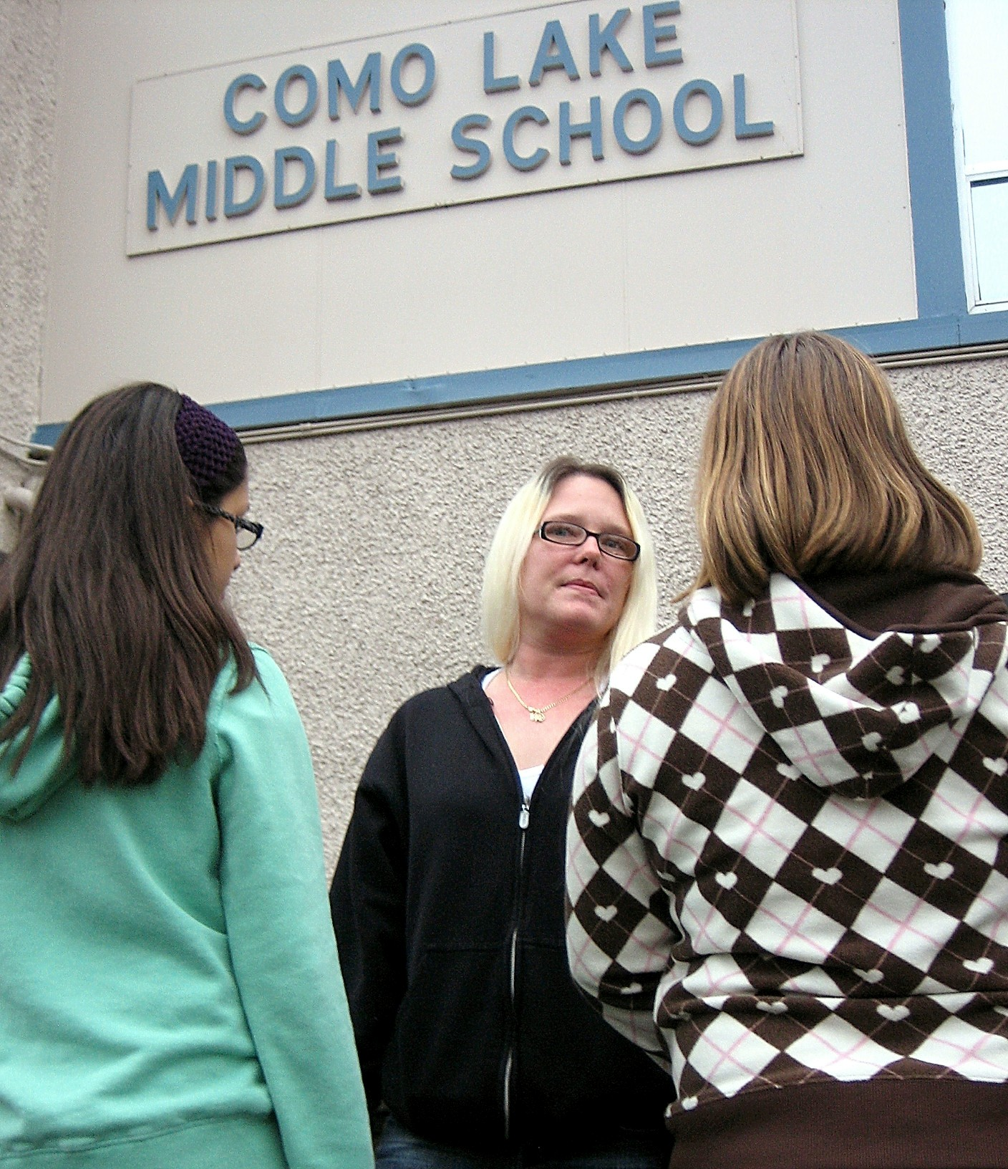 Kateslem Director Karyn Bell

## Focusing on TV in the Tri-Cities

## Kateslem program plants seeds of success

## Coquitlam’s SAR secures its future with foundation fund

**C**oquitlam Search and Rescue’s four-decade-long commitment to the community helps explain why it decided in 2003 to establish the Coquitlam Search and Rescue Society Fund with the Coquitlam Foundation—just one of 23 donor-advised funds the Coquitlam Foundation manages. Search Master Ian MacDonald explained that the society set up the fund because it wanted to ensure that it would have sufficient resources to equip searchers should provincial and municipal funds suddenly dry up.

“We needed to have some sort of financial cushion to protect ourselves, so the thought was to create a fund in perpetuity, one that would use the interest from the fund to help finance our operations,” he said.

Fortunately, government and private funding has continued to flow and the initial $20,000 fund (half dedicated by the society and the other half by the Coquitlam Foundation itself) grew to $140,000 by late 2016, allowing the society to withdraw $60,000 for its new mobile-command centre while retaining $80,000 for future use.

**L**aunched in 2009, the Peter Legge Literacy Endowment Fund is designed to provide enhanced education and literacy opportunities for students and their families in School District 43. A life-long reader, enthusiastic book collector, successful magazine publisher, author and inspirational speaker, Legge (pictured with foundation director Colleen Talbot) was motivated to establish the fund because he is a firm believer in the power of the printed word to change individuals and, through that change, transform the world.

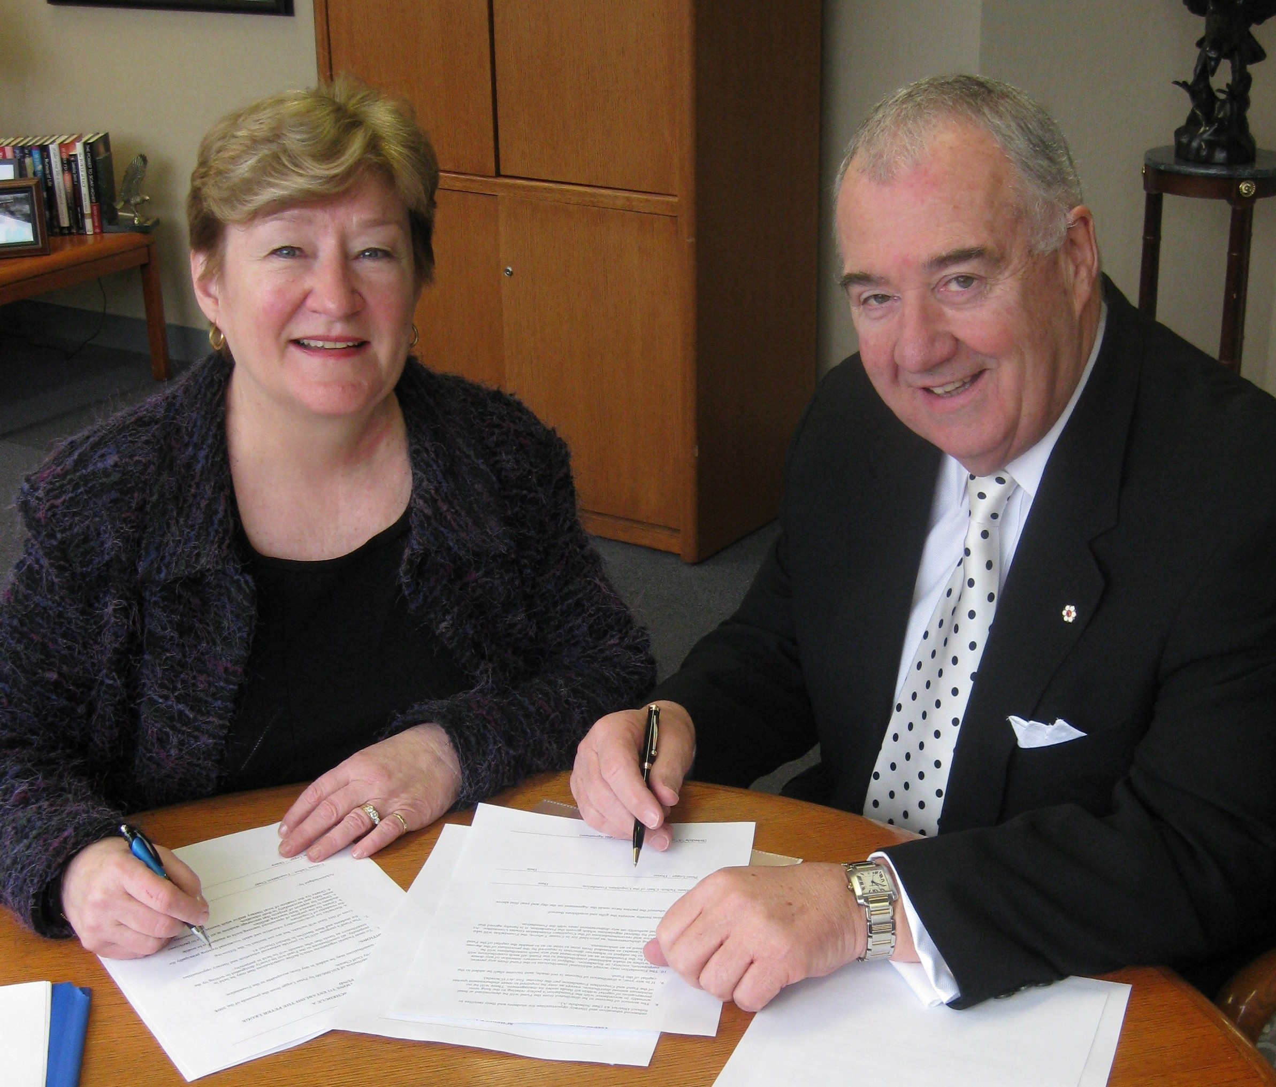

## Literacy fund is Legge’s lasting legacy

**J**ames Gordon Stewart was always simply “Jim” to his family. But by the time he passed away on December 30, 2009 at the age of 83, Jim Stewart had outlived his immediate family and close relatives.

Nevertheless, while Jim might have had few loved ones left in his life during his final years, he still loved the life he had lived in Coquitlam and wanted to give something back.

That is why, when it came time to write his will, he decided to give the bulk of his estate to the city’s leading diversified philanthropic organization, the Coquitlam Foundation. He left clear instructions for the funds to be used for research into Alzheimer’s Disease and kidney disease, and to assist patients afflicted by those diseases. As well, he directed the foundation to use the funds to provide financial assistance to Tri-Cities students attending Simon Fraser University.

And so, in early 2012, the foundation established the James Gordon Stewart Fund. The fund was seeded with $355,588 from the estate of the late Mr. Stewart—the largest single donation in the foundation’s history.

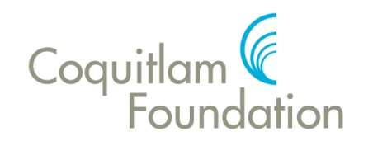

invest. enrich. inspire

## A Coquitlam man’s gift to the community he loved

**Coquitlam Foundation**  
c/o 1207 Pinetree Way,   
Coquitlam, B.C.,  
V3B 7Y3

604.468.9598

info@coquitlamfoundation.com



facebook.com/CoquitlamFoundation

www.coquitlamfoundation.com

**E**ligible applicants for grants, bursaries or scholarships include local individuals and groups, subject to the requirement that the grants be made primarily for the benefit of Coquitlam citizens.

Community organizations should be registered with the Canada Revenue Agency and the commitment of the organization must be to the citizens of the City of Coquitlam.

The foundation limits the frequency of grants it awards to an individual or organization to two consecutive years.

The Coquitlam Foundation supports a number of areas of interest, including youth and seniors, health delivery and support, community services, public safety, people at risk, education, heritage, the environment and arts and culture.

The foundation publishes advertisements every January requesting grant and bursary applications. The closing date for applications is usually late February. Awards are distributed in the spring.

**T**here are several ways individuals or organizations can team with the foundation to supports its community work. They can donate to an already-existing fund or make an unrestricted donation to be used at the foundation’s discretion. Interested parties can also establish funds, to be managed by the foundation, to support specific causes or initiatives.

And, finally, anyone in the community can support us by attending our fundraising events. Watch our website upcoming events.

## How we can help you. How you can help us

*Philanthropy Plus*

*‘When your heart tells you it’s time to help people in your community, but your head doesn't know where to turn, it's time to look to the Coquitlam Foundation. We're your hometown partner in philanthropy, helping you help your neighbours through charitable initiatives as simple as a one-time donation to our general fund or as profound as the establishment of an endowment fund. Look to the Coquitlam Foundation when you're looking to help.’*

**Canada Revenue Agency Charitable Registration Number 890762347 RR0001**

**Board Members (2018)**: Roch Ripley, Chair, John Wolff, Vice-chair, Sid Sharma, Secretary, Justina Mark, Treasurer, Richard Stewart, (City of Coquitlam), Barb Hobson, (School District 43), Andrea Jabour (Tri-Cities Chamber of Commerce), Colleen Talbot, Adel Gamar, Trish Mandewo, Linda Meneghello, Linda Reimer.

**Honorary Chair**: Peter Legge. **Executive Director**: Dwight Yochim

**Donor-Advised Funds**

*Family/Memorial Funds*: [Beverley Ann Cook Fund](http://www.coquitlamfoundation.com/donorfunds#cook), [Carleigh Rae LeClair Fund](http://www.coquitlamfoundation.com/donorfunds#rae), [CMLA Brodie Campbell Memorial Scholarship Fund](http://www.coquitlamfoundation.com/donorfunds#campbell), [Coquitlam Metro Ford Domenic Mobilio Bursary Fund](http://www.coquitlamfoundation.com/donorfunds#mobilio), Raymond A. LeClair Scholarship Fund, [Shelagh Elaine Fulton Memorial Fund](http://www.coquitlamfoundation.com/donorfunds#fulton), [Symington Endowment Fund](http://www.coquitlamfoundation.com/donorfunds#symington), Danielle and Gary Couling Education Fund, Trevor Wingrove Bursary Fund. *In development:* Bill LeClair Community Fund. *Agency Funds*: [Coquitlam Centre Fund](http://www.coquitlamfoundation.com/donorfunds#coquitlamcentre), [Coquitlam Public Library Living Legacy Fund](http://www.coquitlamfoundation.com/donorfunds#library), [Coquitlam Stroke Recovery Fund](http://www.coquitlamfoundation.com/donorfunds#stroke), Friends of Mundy Park Heritage Society Fund, [Rotary Club Community Service Award,](http://www.coquitlamfoundation.com/donorfunds#rotary) [Tri-Cities Chamber of Commerce Elite Athletes Fund](http://www.coquitlamfoundation.com/donorfunds#elite), Coquitlam Search and Rescue Fund, Evergreen Arts Education Endowment Fund, Soroptimist TriCities Fund. *Specialty Funds*: [Community Diversity Fund](http://www.coquitlamfoundation.com/donorfunds#diversityfund), [Mayor's Community Fund](http://www.coquitlamfoundation.com/donorfunds#mayorsfund), [Peter Legge Literacy Endowment Fund](http://www.coquitlamfoundation.com/donorfunds#legge), Steps Together Fund, Michael Coss Brain Injury Fund, Noura Homes Community Fund.

**Foundation-Directed Funds** James Gordon Stewart Fund, Coquitlam Foundation Community Fund, Johnston Legacy Fund, Della and Cam Grant Fund, CF 125 Legacy Fund.